1. The purpose of Docker Compose is not only to automate some of those long winded commands, it is also to make sure that we have the ability to easily start up multiple docker containers at the same time and connect them together in some automated fashion.
2. 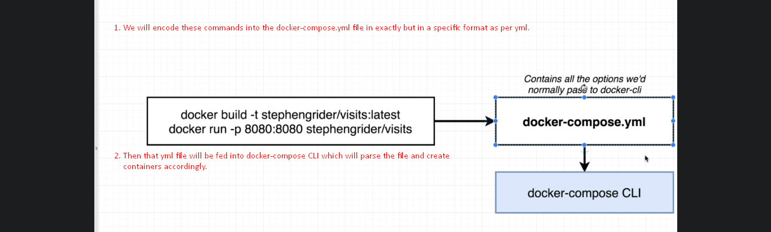
3. 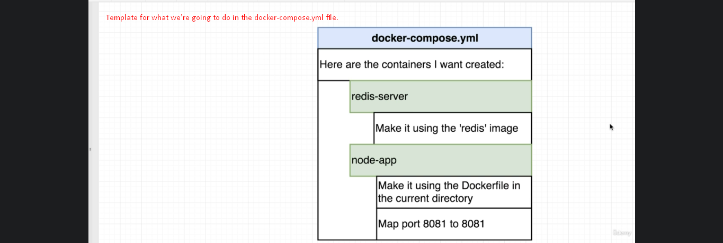
4. Step 01:  
   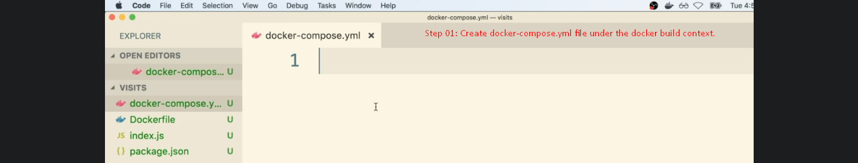
5. 